***LOCATION:***

*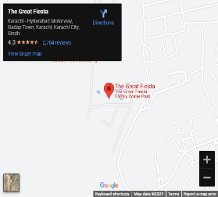Survey No. 25, Deh Amilano Tappo Kathore,*

*Main Super Highway, Karachi*

*+92 333 3529940/41*



*+92 336 3529940/41*

[*info@thewaterworld.com*](mailto:info@thewaterworld.com)